DAY12

Class Exercise 1

    @PostMapping("/employee")

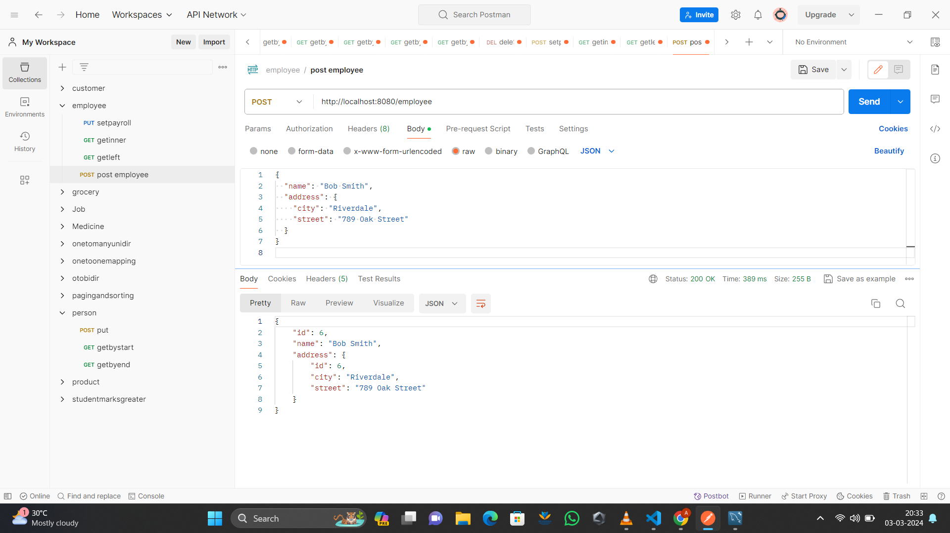

    @GetMapping("/employees-inner-join")

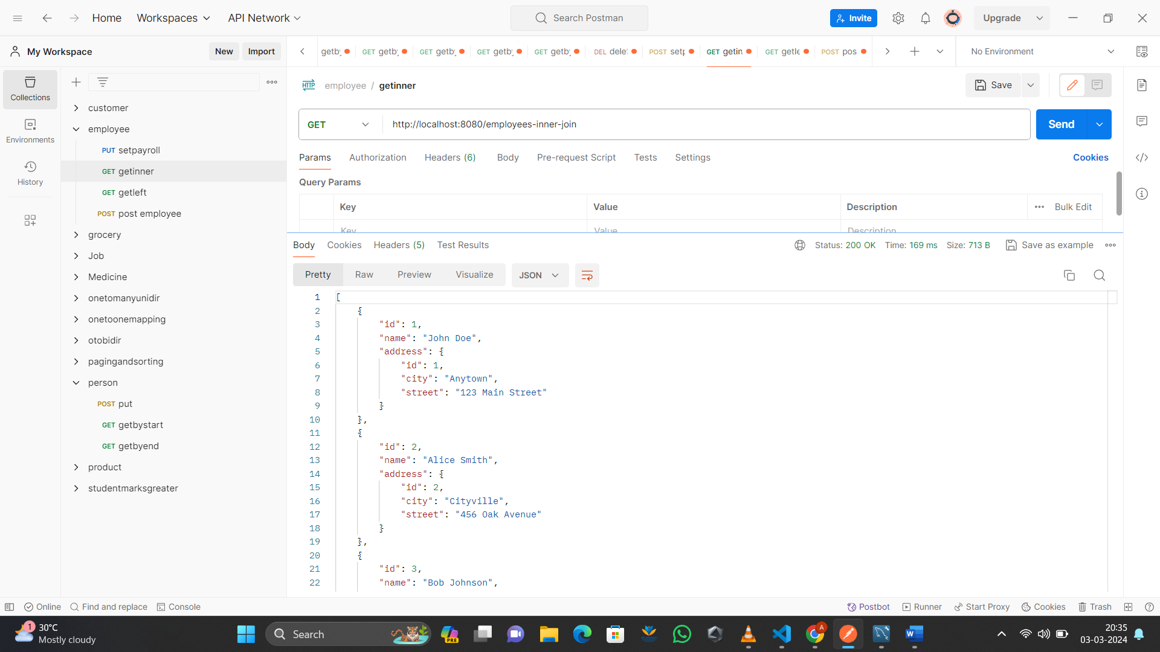

    @GetMapping("/employees-left-outer-join")

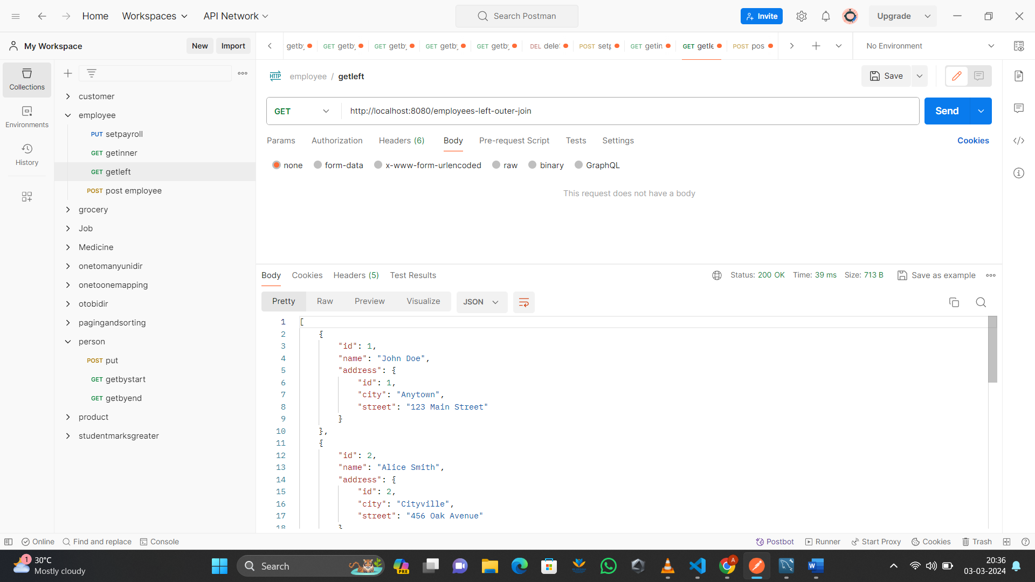

    @PostMapping("/address/employee/{id}")

